Melina Russo  
867596

Project Overview & Current Issues

The main interest of my research is that now that the internet and social media are widely used as means of communication, a new kind of grammar is emerging, which might on first impression appear as just “ungrammatical English” or a more informal variety, but instead uses punctuation and sentence structure in a different way from standard English grammar to convey meaning.

While many “personal quirks” can be found in anyone’s written language (such as the use of ellipsis to give a different tone to a declarative sentence in Pic 1), what has been considered interesting is that the extent to which the internet and social media are used now has made it so that this grammar is “codified” across different communities in different dialects. It is not just a matter of “SMS speak” or shortened forms to save space, although Twitter’s character limit still influences whether one might choose to use them – actually, shortened forms are present even in contexts where the tweet was staying perfectly in range of the character limit otherwise, in order to, again, convey different tone or emotion (as in Pic 5).

“New grammars” seem to influence all areas of speech, from punctuation to vocabulary choice. For example, in Pic 4 it may appear that punctuation is simply missing due to space or carelessness when typing, but to someone used to the same language patterns, it will give the impression of “rambling” or “ranting”. While it’s possible to find accounts that only speak with this pattern, it is much more common for there to be a gradual switch between more traditional standard punctuation and more informal texting style of punctuation across the same account, in accordance with the topic at hand. This is fairly common with accounts that post both political commentary and jokes/memes/personal news.

Sometimes the “wrong” registry is chosen in order to obtain a humoristic or surreal effect, such as is the case for 2 or 3. In the first case “strict” twitter/internet slang (siccing, blasting) coupled with very informal speech patterns is used to discuss a previous exchange that happened between two political accounts (one of them belonging to a scholar). In the second, traditional and grammatical, somewhat formal English is used to make an overdramatic statement.

The first case also highlights how much new word production the environment of social media is able to stimulate.

1.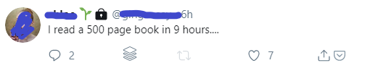

2.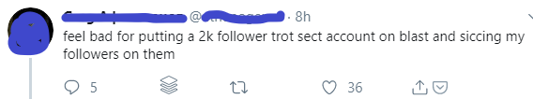

3.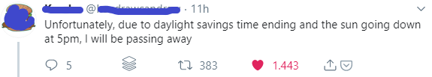

4.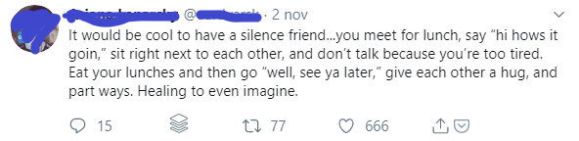

5.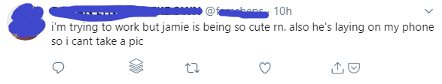

These are, of course, just a handful of examples that I thought a good representation of what appears to be trends in different communities on Twitter and the scope of the specialization its dialect is experiencing. Theory about this phenomenon is still scarce, with the most important conceptualization of “a linguistics subfield for the internet” being that of David Crystal, who I already mentioned.

As I see it, in order to get a proper analysis out of this, the most relevant issues are as follows:

* The variety of elements to account for (punctuation, word choice, sentence structure as dependent on multiple factors) and, in choosing what to focus on, struggling what to consider more important for the analysis.
* I could search a corpus for strings or trees that I already noticed or have been already pointed out by scholars, but that’s not quite what I wanted to do: I wanted for the analysis to be a large-scale identifier of these patterns.